**Product**

AEGIS, The Most Advanced and Widely used **Antimicrobial Surface Treatment** on the Planet.

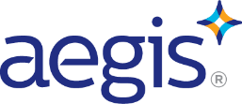**SAFE – LONGTERM – DURABLE – EFFECTIVE – 24/7 – 365 PROTECTION**

AEGIS has been used for over 30 years to control and prevent microbial growth across many industries. i.e. hospitals, schools, subways, buses, sports arenas, office buildings, gas stations, dentists, airplanes, airports, cruise ships, apartment buildings/residential homes, racetracks, hotels, commercial office buildings, restaurants, medical offices to name a few.

AEGIS is likely already a part of your life. If the keyboard, mouse, or mousepad at your computer say Microban – then you are already touching AEGIS. If you are wearing ***Nike, Reebok, Adidas, Under Armour, Crocs or Rockport*** - then you are likely already wearing AEGIS. Each of these products use AEGIS to control and prevent microbial growth in their shoes, socks, shirts, etc.

**Competitive Products on the Market**

Conventional disinfectants (alcohol, chlorine, bleach etc.) are only effective till they dry. They give you **short term protection** until the next person touches, sneezes, etc. on or near the surface. In general, it lasts only minutes and you will need to continually reapply to ensure sanitation of surfaces and thus personal protection from pathogens.

**Company and Technology**

For over 30 years AEGIS has been the world’s most widely used antimicrobial. Used on both hard and soft surfaces, **AEGIS is an enduring antimicrobial surface treatment that provides ongoing surface protection for up to 1 year**. AEGIS forms a protective coating that molecularly bonds with products upon application and inhibits the growth of microbes on surfaces. When applied to surfaces, AEGIS forms a colorless, odorless, positively charged polymer that attracts, then electrocutes, ruptures, and disintegrates a microbe’s negatively charged cell membrane. AEGIS has a history of safe use and durability, ensuring long-lasting antimicrobial efficacy and is used by name brand manufacturers globally.

**Why AEGIS is Different**

AEGIS is not function like a conventional disinfectant or cleaner, it is an antimicrobial that provides a mechanical method of control. Compared to traditional products AEGIS has many benefits:

1. 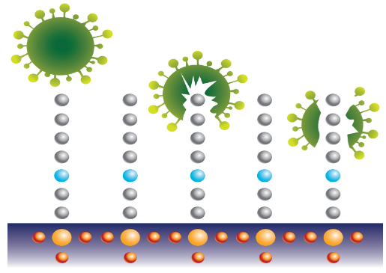AEGIS does not leave the surface when applied. Conventional products penetrate living cells and kill by way of poisoning the organism or disrupting a vital life process - they are designed to act and dissipate quickly.

2 AEGIS lasts on most surfaces for up to a year or longer. *Most commercial antimicrobials do an adequate job of controlling bacteria and fungi but have a limited range.*

3) AEGIS has been tested to be effective on many surfaces including glass, fabric, metal, and plastic.

4) AEGIS is the only globally registered antimicrobial and used by name brand manufacturers.

5) AEGIS creates an inhospitable environment for microbes to live on and will not create resistant organisms.

**Technology­** - ***Proven to be the most durable and effective antimicrobial. Period.***

The active chemical ingredient is a quaternary ammonium salt, which is chemically spliced to a silane molecule, resulting in a highly active material (3-trimethoxsilyl propyldimethyloctadecyl ammonium chloride, called AEM5700) that has both tenacious bonding capabilities as well as excellent antimicrobial properties. During the application process, stable bonds form between the OH- sites on the AEM5700 molecule and the positive charge on the nitrogen atoms (N+). The result of this chemical process is the creation of a large copolymer that chemically bonds AEGIS to the target substrate.

AEGIS has been tested to be effective on many surfaces including glass, fabric, metal, and plastic to control and prevent microbial growth including bacteria, fungi, mold, mildew, and algae.

*Hard and finished surfaces* (concrete, wood, plastic, drywall, masonry supplies, glass, rubber, stainless steel, and much more. *Textiles, woven, and porous materials* (carpet, upholstery, linens, clothing, sports equipment, vehicles, janitorial cleaning equipment).

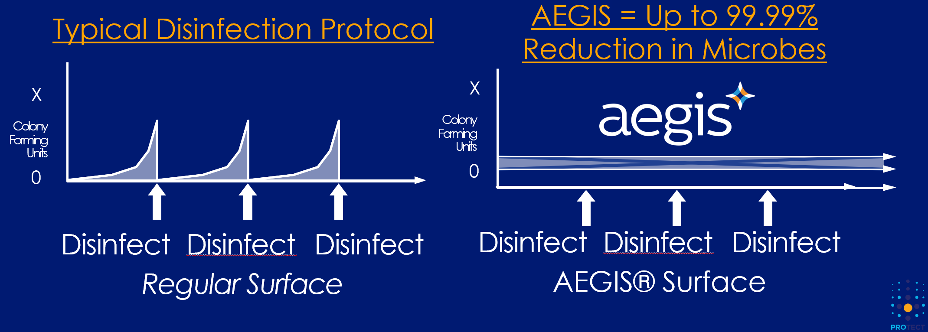

**Independent Test Results**

Testing was conducted by independent labs, showing the sustained decrease in surface microbial contamination. AEGIS can be weakened or deactivated over time by highly caustic materials

(pH 11+). Testing was conducted by independent labs, showing the sustained decrease in surface microbial contamination. *Additional tests and case studies available upon request.*

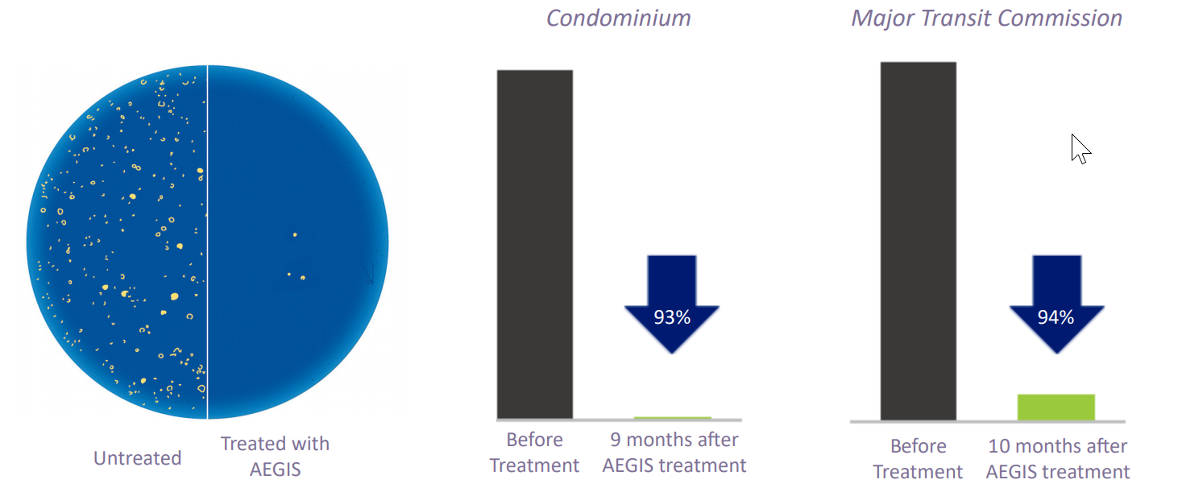

**Global Certifications and Approvals**

AEGIS is not a disinfectant. AEGIS is registered with health authorities around the world including Health Canada and the US Environmental Protection Agency (EPA).

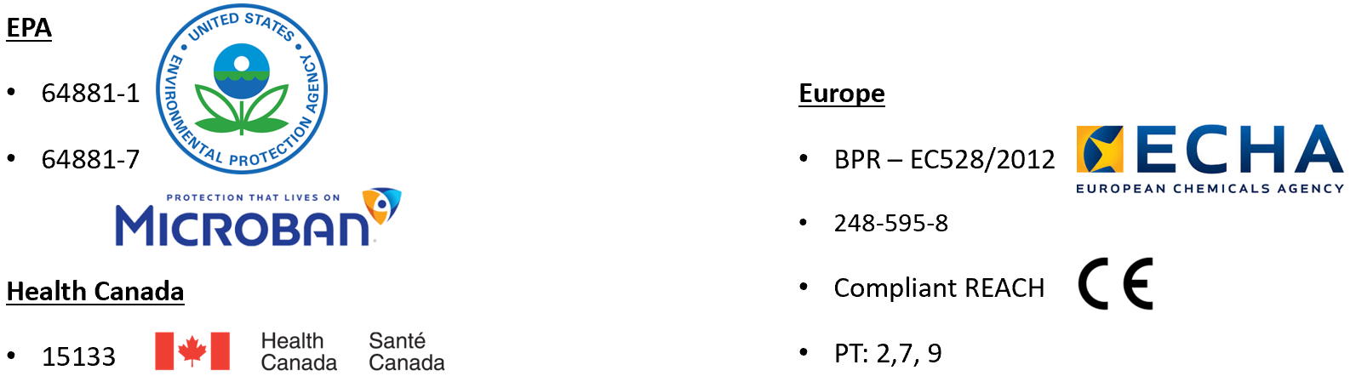

**Application Options**

BioProtect Innovations and AEGIS offer industry leading options to include - Direct Product Sales, Employee Applicator Training and Turn-Key Programs available including Application Service.

**Global Customers (Partial List)**

* Netflix and FOX network recording studios
* 7-Eleven
* Starwood Hotels & Resorts Worldwide, Inc
* Shangri-La Hotels and Resorts
* New York City Transit
* Bombardier Transportation
* Nike
* Reebok
* Adidas
* Under Armour
* Crocs
* Rockport Footwear
* Ohio State University James Cancer Research Center-Columbus, OH
* M. D. Anderson Cancer Center-Houston, TX
* The Phoenix Heart Institute-Phoenix, AZ
* Northwestern University Hospital-Chicago, IL
* Minnesota Vikings Training Facility-Minneapolis, MN
* Miami Heat Training and Locker Facilities-Miami, FL
* Cleveland Browns Training and Locker Room Facilities-Cleveland, OH
* Atlanta Hawks and Atlanta Thrashers Athletic Facilities-Atlanta, GA
* Milwaukee Bucks Training and Locker Facilities-Milwaukee, WI
* Detroit Pistons Training and Locker Room Facilities -Detroit, MI